GRADE | 10 | SUBJECT |  | CAT |  | WEEK |  | W2  L1 |  | TOPIC | Network Technologies: Network Basic Concepts
LESSON SUMMARY FOR:
DATE STARTED |  |  |  |  |  |  | DATE COMPLETED
LESSON OBJECTIVES |  |  | At the end of this lesson the learner must be able to:  - Know what a network is  - Requirements for a network  - State advantages and disadvantages of networks
TEACHER ACTIVITIES |  |  |  |  |  |  |  |  | LEARNER ACTIVITIES |  |  |  | TIMING | RESOURCES NEEDED
1. Methodology  - Individual work  - Power point presentation  - Class Discussion with reference to text book  - Internet references  2. Introduction  Introduce learners to:  - The concept of networks:  A network is the practice of linking two or more computing devices together for the purpose of sharing data.  - The Basic necessities to set up a networks : Hardware and software requirements  - Methods of communication  - The types of networks  3. Main Body (Lesson presentation)  Networks are built with a mix of computer hardware and computer  software  Aim and Objectives of networks :  Primary aim is to SHARING  A computer network allows sharing of information and resources among interconnected devices.  The facilitating of communication between people, information preservation.  Sharing software and hardware  Sharing files, data, and information  Requirements for a network connection :  - Building a network consists partly of connecting the computers:  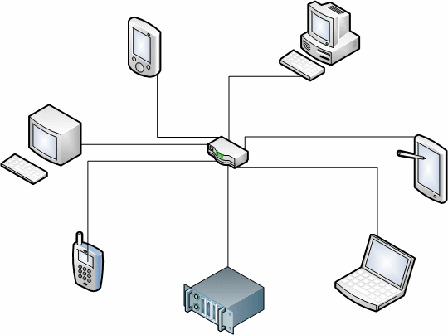  Cable is used to connect computers.  A hub is rectangular box that is used as the central object on which computers and other devices are connected. To make this possible, a hub is equipped with small holes called ports. Here is an example of a hub:  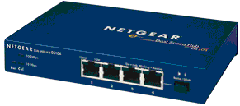  Although this appears with 4 ports, depending on its type, a hub can be equipped with 4, 5, 12, or more ports. Here is an example of a hub with 8 ports:  In most cases for a home-based or a small business network, you may not need (or shouldn't use) a hub.  Like a hub, a router is another type of device that acts as the central point among computers and other devices that are part of a network. Here is an example of a wired router:  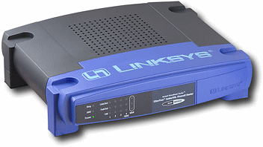  A router functions a little differently than a hub. In fact, a router can be considered a little "intelligent" than the hub.  Like a hub, the computers and other devices are connected to a router using network cables. To make this possible, a router is equipped with holes, called ports, in the back. Here is an example:  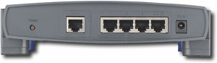  In order to connect to a network, a computer must be equipped with a device called a network card. (NIC) A network card, or a network adapter, also called a network interface card, or NIC, allows a computer to connect to the exterior. If you buy a computer from one of those popular stores or big companies on the Internet, most of their computers have a network card tested and ready. You can reliably use it. If you go to a store that sells or manufactures computers, you can ask them to install or make sure that the computer has a network card.  In order to connect the computers to the network  Wireless connectivity  The key hardware components of a wireless computer network include adapters and access points, antennas and repeaters.  Software needed:  A network operating system is needed to connect a network  Advantages of networks :  The facilitating, communications and sharing of hardware,  software, data and information:  File Sharing  The major advantage of a computer network is that is allows file sharing and remote file access. A person sitting at one workstation that is connected to a network can easily see files present on another workstation, provided he is authorized to do so. This saves him/her the hassle of carrying a storage device every time data needs to be transported from one system to another. Further, a central database means that anyone on that network can access a file and/or update it.  Resource Sharing  If there are twelve employees in an organization, each having their own computer, they will require twelve modems and twelve printers if they want to use the resources at the same time.  Inexpensive Set-Up  Shared resources mean reduction in hardware costs. Shared files mean reduction in memory requirement, which indirectly means reduction in file storage expenses. A particular software can be installed only once on the server and made available across all connected computers at once. This saves the expense of buying and installing the same software as many times for as many users.  Flexible Handling  A user can log on to a computer anywhere on the network and access his files. This offers flexibility to the user as to where he should be during the course of his routine. A network also allows the network administrator to choose which user on the network has what specific permissions to handle a file. For example, the network administrator can allot different permissions to User A and User B for File XYZ. According to these permissions, User A can read and modify File XYZ, but User B cannot modify the file. The permission set for User B is read-only data.  Increased Storage Capacity  Since there is more than one computer on a network which can easily share files, the issue of storage capacity gets resolved to a great extent. When many computers are on a network, the memory of different computers can be used. One can also design a storage server on the network in order to have a huge storage capacity.  The facilitating of electronic funds transfer (EFT)  A network provides the ability to make payments over the  internet at any time of the day and place.  Disadvantages of Networks  Security Concerns  One of the major drawbacks of computer networks is the security issues that are involved. If a computer is a standalone computer, physical access becomes necessary for any kind of data theft. However, if a computer is on a network, a hacker can get unauthorized access by using different tools. In case of big organizations, various network security software needs to be used to prevent theft of any confidential and classified data.  Privacy Concerns  If the network security is not properly set up, there is a danger that personal information may fall into the wrong hands  Virus and Malware  If even one computer on a network gets affected by a virus, there is a possible threat for the other systems getting affected too. Viruses can spread on a network easily, because of the inter-connectivity of workstations. Moreover, multiple systems with common resources are the perfect breeding ground for viruses that multiply. Similarly, if malware gets accidentally installed on the central server, all clients in the network that are connected to that server will get affected automatically.  Lack of Robustness  If the main file server of a computer network breaks down, the entire system becomes useless. If there is a central linking server or a bridging device in the network, and it fails, the entire network will come to a standstill. In case of big networks, the file server should be a powerful computer, which often makes setting up and maintaining the system doubly expensive.  Needs An Efficient Handler  The technical skills and know-how required to operate and administer a computer network is considerably high. Any user with just the basic skills cannot do this job. Also, the responsibility that comes with such a job is high, since allotting username-passwords and permissions to users in the network are also the network administrator's duties. Similarly, network connection and configuration is also a tedious task, and cannot be done by an average user who does not have advanced knowledge of computers and/or networking.  Lack of Independence  Since most networks have a centralized server and dependent clients, the client users lack any freedom whatsoever. Centralized decision making can sometimes hinder how a client user wants to use his own computer.  Computer networks have had a profound effect on the way we communicate with each other today, and have made our life easier. From the World Wide Web to your local office LAN, computers have become indispensable in daily life, and networks have become a norm in most businesses. If networks are designed and configured keeping in mind its pros and cons, they are the best piece of facility you could ever have.  Source:  http://compnetworking.about.com/cs/wireless/f/wirelesshardwar.htm  http://www.functionx.com/networking/Lesson02.htm  4. Conclusion  Revise terminology.  Learners to summarise concepts  Networks , Protocol, LAN, WAN, GAN , PAN |  |  |  |  |  |  |  |  | Folder Data Files for learners to practice  Use the Worksheet for learners.docx (DATA FILES) word document to expand knowledge |  |  |  | Introduction and definition 10 minutes  The rest of the time allocated on explanation of the lesson  Computers  Part of your Life  p. 105  Via Afrika  p.78 Act 1  p 71 Act 2  Focus  p. 141 Act 4  p 143 | PowerPoint presentation  Data projector  Prescribed Textbooks  Computers  Part of your Life  p. 99-100  Via Afrika  p.76-81  Focus  p. 139- 140
  Network Cables
  Hub
  Routers: Wired or Wireless
  Wired Network Cards: Internal
  Switch -

Name of Teacher: HOD:
Sign: Sign:
Date: __________________ Date:

